**State University of New York at New Paltz**

**Erick Thompson**

**S22-52**

**REPORT for PROJECT # 02**

(Advanced SQL)

**CPS593-04 “Database Management Systems”**

**(Professor Hanh Pham)**

**Summer 2022**

**TABLE OF CONTENTS**

**Business Situation ..………………………………………………………………………………………………………………….………. 3**

STEP-1: **CHANGE** the **data type** of a COLUMN in a table **……………………………………………………………………… 4**

STEP-2: **GET/Retrieve** particular data using a keyword (with WHERE … = "keyword";) **…………………………. 4**

STEP-3: **Make a COPY** of a table **…………………………………………………………………………………………………………. 5**

STEP-4: **DELETE** a table **………………………………………………………………………………………………………………………. 5**

STEP-5: **FILTER** and **SORT** data from a table using **ORDER BY clause** **…………………………………………………… 6**

STEP-6: Use **SQL functions** to **get MAX, MIN, AVE** … based on data from a table **………………………………… 6**

STEP-7: Use **SQL function COUNT** to get define the size of data from a table **………………………………………. 7**

STEP-8: Using **DISTINCT** clause **…………………………………………………………………………………………………………… 7**

STEP-9: Using **GROUP BY** clause **………………………………………………………………………………………………………… 8**

STEP-10: Use **HAVING** clause **…………………………………………………………………………………………………………….. 8**

**Business Situation**

A businessman wants to keep track of coffee cup sales in a state. They store data about each cup size, which store the cups were sold to, and the average number of cups that were sold to the store for a specific size. Due to a recent cup shortage, we want to target which cup size is being used the most so that the businessman can inform the business which cup to increase production in.

Additionally, since this businessman was recently promoted and now tracks cup sales on the whole east coast, he needs to expand his research and keep track of more cup sales. The businessman wants to see where the minimum and maximum number of cups are sold and create more tables in his database to store more cup sales data.

The data we have in step-10 after project 1 in the table “CAFES” are:

**Table CAFES**

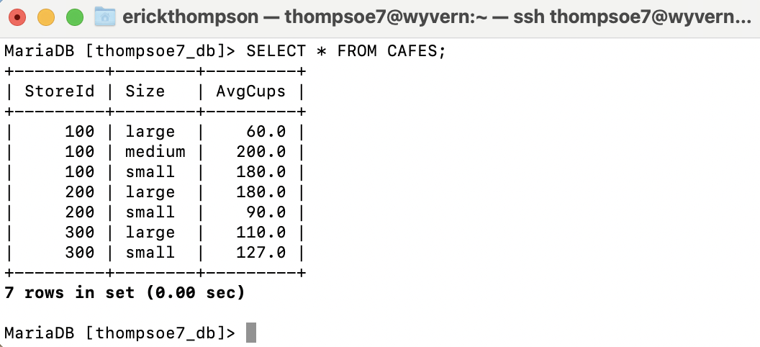

STEP-1: **CHANGE** the **data type** of a COLUMN in a table:

**ALTER TABLE CAFES MODIFY COLUMN AvgCups INT(3);**

STEP-2: **GET/Retrieve** particular data using a keyword (with WHERE … = "keyword";)

**SELECT StoreId, AvgCups FROM CAFES where Size='large';**

STEP-3: **Make a COPY** of a table

**CREATE TABLE NewCafe AS (SELECT * FROM CAFES);**

STEP-4: **DELETE** a table;

**DROP TABLE NewCafe;**

STEP-5: **FILTER** and **SORT** data from a table using **ORDER BY clause**

**SELECT AvgCups FROM CAFES WHERE size = 'large' ORDER BY AvgCups DESC;**

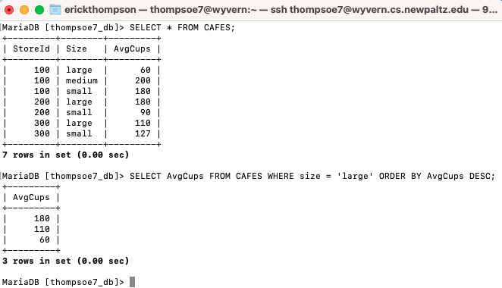

STEP-6: Use **SQL functions** to **get MAX, MIN, AVE** … based on data from a table

**SELECT MAX(AvgCups) FROM CAFES WHERE StoreId = '100';**

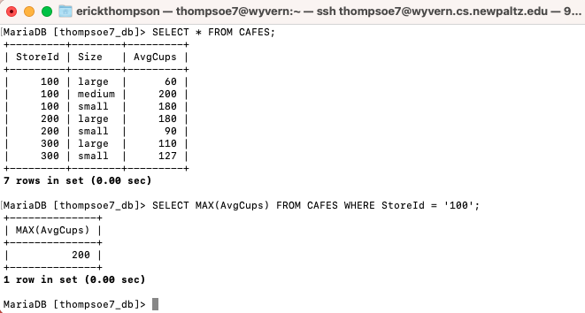

STEP-7: Use **SQL function COUNT** to get define the size of data from a table

**SELECT COUNT(*) AS "Big Orders" FROM CAFES WHERE Avgcups > 150;**

STEP-8: Using **DISTINCT** clause

**SELECT COUNT(DISTINCT Size) AS "Unique Sizes" FROM CAFES WHERE AvgCups < 300;**

STEP-9: Using **GROUP BY** clause

**SELECT Size, COUNT(*) AS "Number of Stores" FROM CAFES GROUP BY Size;**

STEP-10: Use **HAVING** clause

**SELECT * FROM CAFES HAVING AvgCups > 100 ORDER BY Size DESC;**

